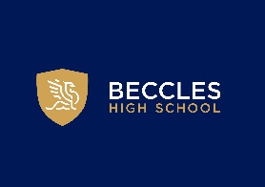

Careers Education, Information, Advice and Guidance
Information for Employers
Revised Jan 2026
Review: September 2027
Beccles High School is committed to building links with local businesses and employers. We feel it is important for employers to understand the current educational landscape, appreciate the skills and knowledge our students can offer and have access to their work force of the future. We host a variety of opportunities for you to interact with students, ranging from assembly presentations, participation in lessons to contextualise curriculum learning in the world of work, careers days, business breakfasts, mock interviews and work experience.
In addition, we want to ensure that our students are work ready and offer them the above range of opportunities as part of our comprehensive careers programme.
If you would like to become part of this network in any way, please contact our Careers Team and they will be happy to answer your query:
Tel: 07831120873
j.stockman@beccleshighschool.org

